

Programming Fundamentals

Assignment No # 04 & 05

Student Name :MOMIN HAYAT KHAN

Roll No: S20-0273

Department :BS(Artificial Intelligence)

Batch / Year:SPRING 2020

Lecturer: Mam Misbah

Assignment No # 04

Program No 1:

|  |
| --- |
| #include <iostream>  using namespace std;  int main(){  int sum ;  sum = 1+2+3+4+5+6+7+8+9+10 ;  cout << sum ;} |

Output:

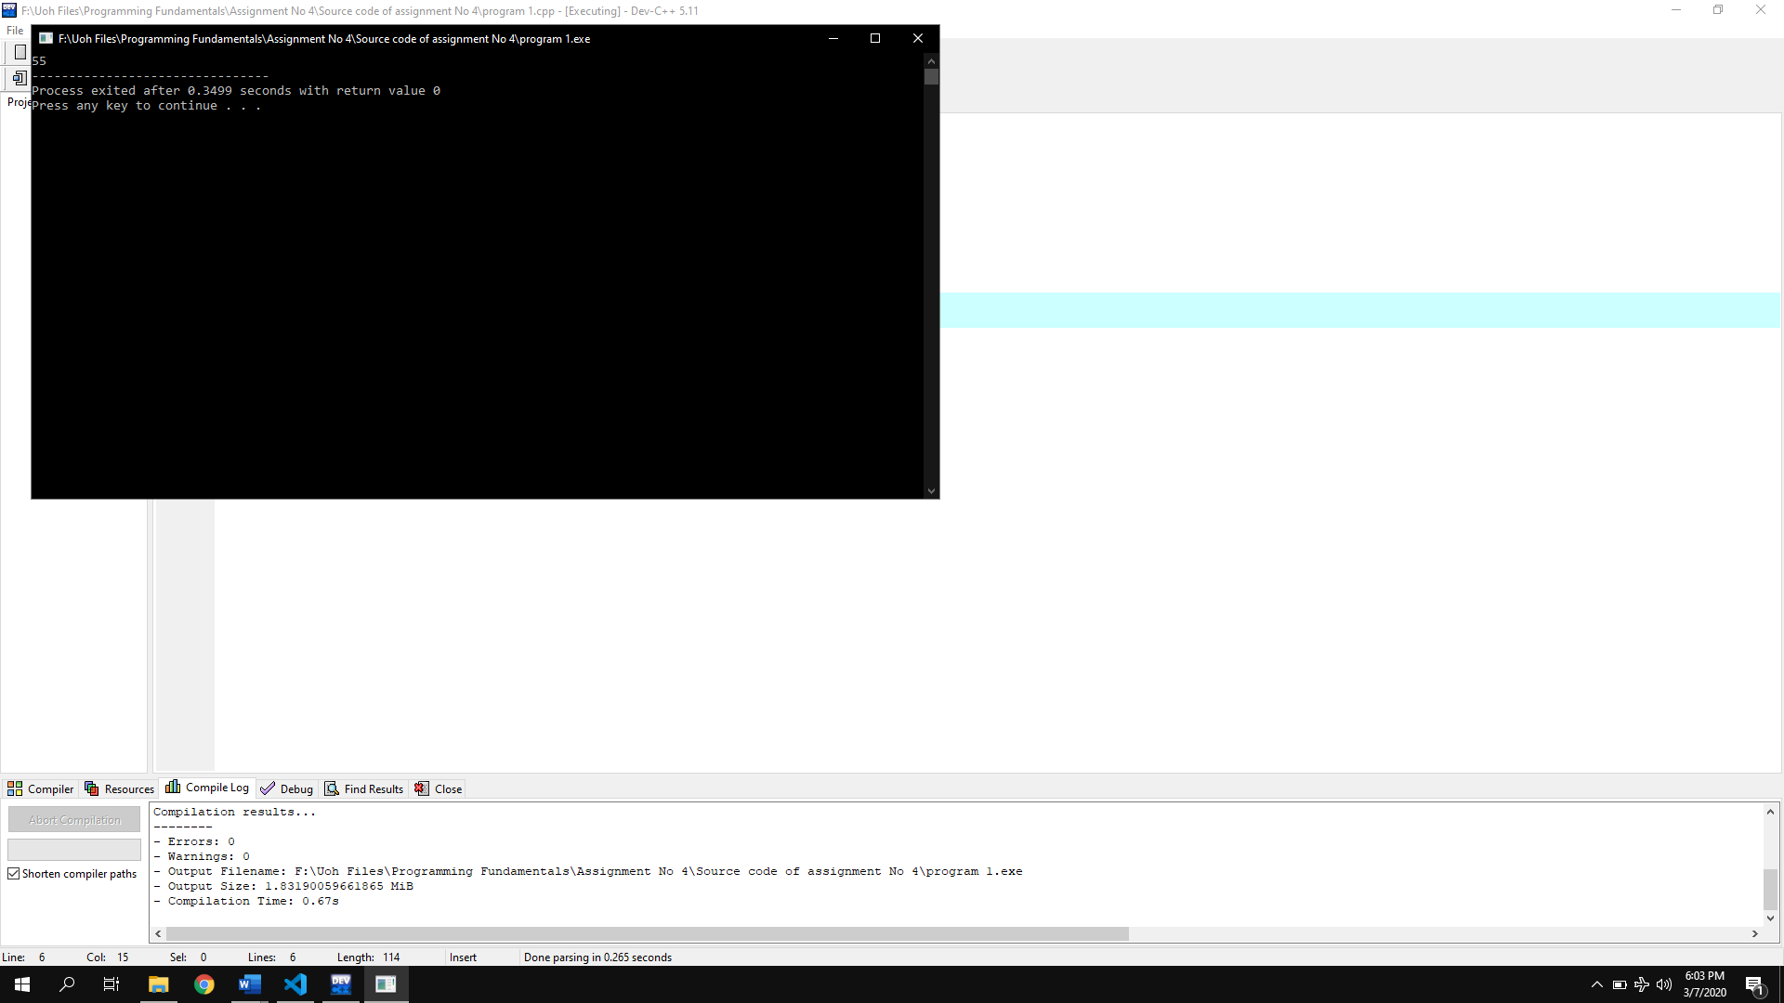

Program No 2:

|  |
| --- |
| #include <iostream>  using namespace std;  int main(){  int sum , number ; sum = 0;  number = 1;  while ( number <= 1000 )  {sum = sum + number ; number = number + 1 ;}  cout <<"The sum of the first 1000 integer starting from 1 is "<< sum ;} |

Output:

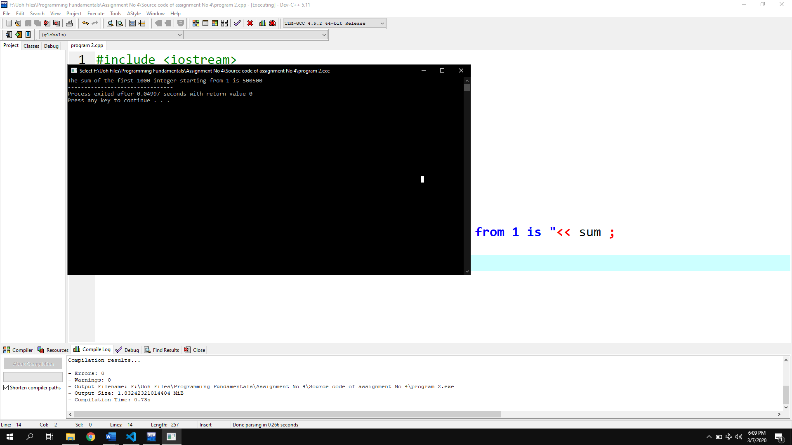

Program No 3:

|  |
| --- |
| #include <iostream>  using namespace std;  int main()  {int number ;  int factorial ; factorial = 1 ;  cout <<"Enter the number of Factorial= ";  cin>>number ;  while ( number >= 1 )  {factorial = factorial * number ;number = number-1 ;}  cout <<"Factorial is "<< factorial ;} |

Output:

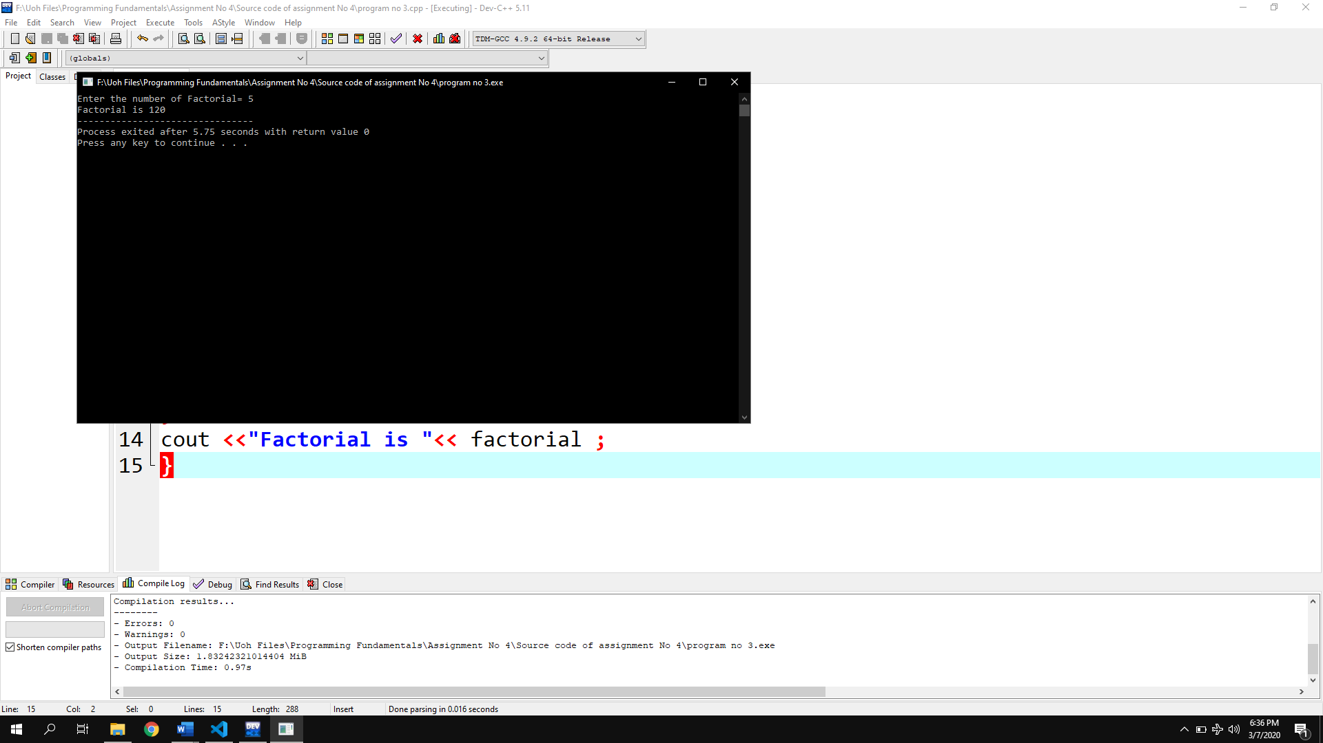

Program No 4:

|  |
| --- |
| #include <iostream>  using namespace std;  int main()  {int counter ;  for( counter = 0 ; counter < 10 ; counter = counter + 1 )  {cout << counter;}} |

Output of the program step by step:

|  |  |
| --- | --- |
| 0 | 1 |
| 2 | 3 |
| 4 | 5 |
| 6 | 7 |
| 8 | 9 |

Output:

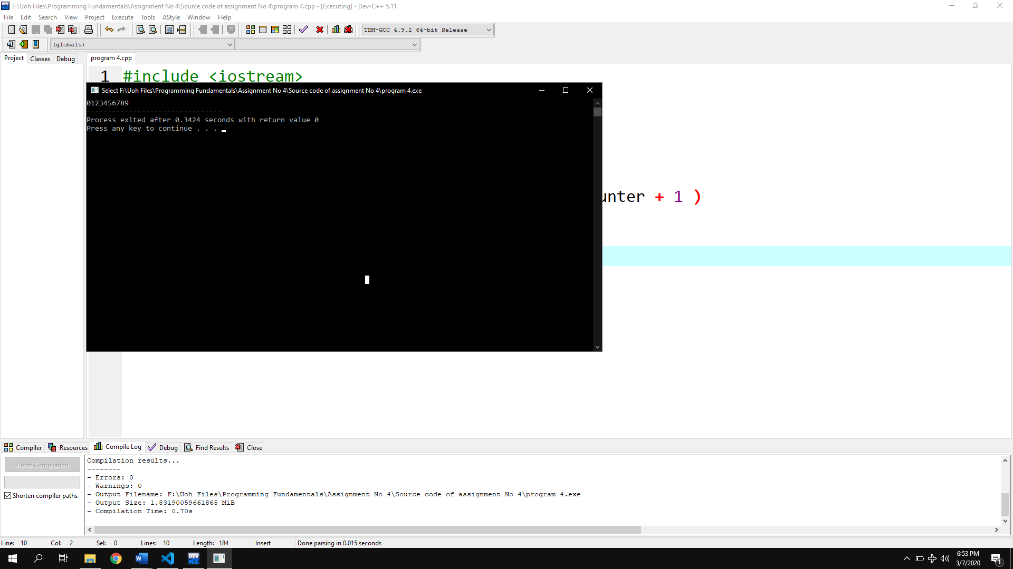

Program No 5:

|  |
| --- |
| #include <iostream>  using namespace std;  int main()  { int counter;  counter=1;  while(counter<=10)  { cout<<2*counter;  cout<<" ";  counter++;}} |

Output:

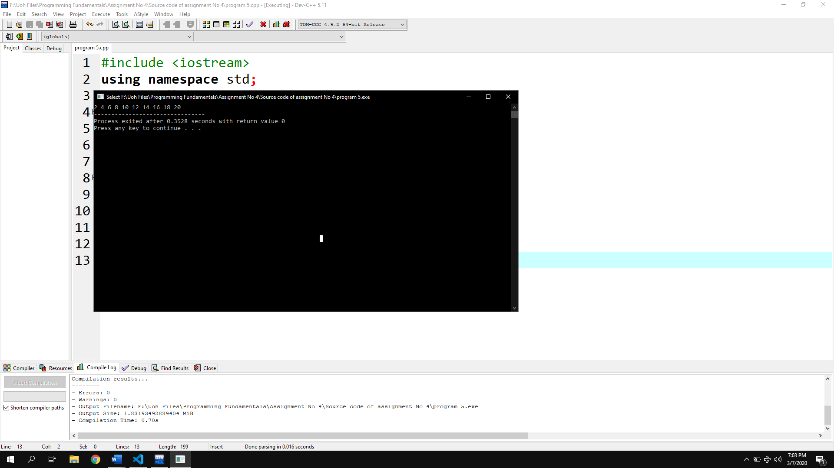

Program No 6:

|  |
| --- |
| #include <iostream>  using namespace std;  int main()  { for(int num=1;num<=1000;num++)  {cout<<num;cout<<",";}} |

Output:

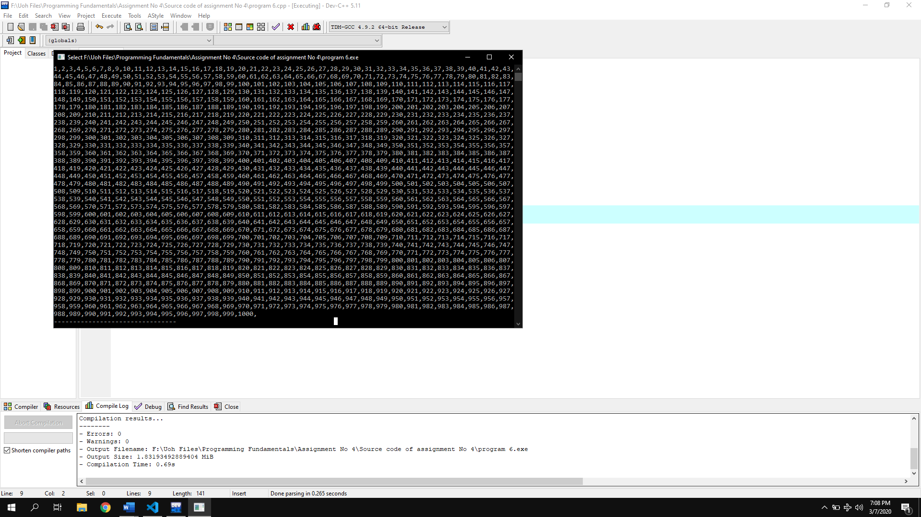

Program No 7:

|  |
| --- |
| #include <iostream>  using namespace std;  int main()  { int i;  cout<<"Enter 0 if you want to exit= ";  cin>>i;  while(i!=0)  {for(int num=1;num<=1000;num++)  {cout<<num;cout<<",";}  break;}} |

Output:

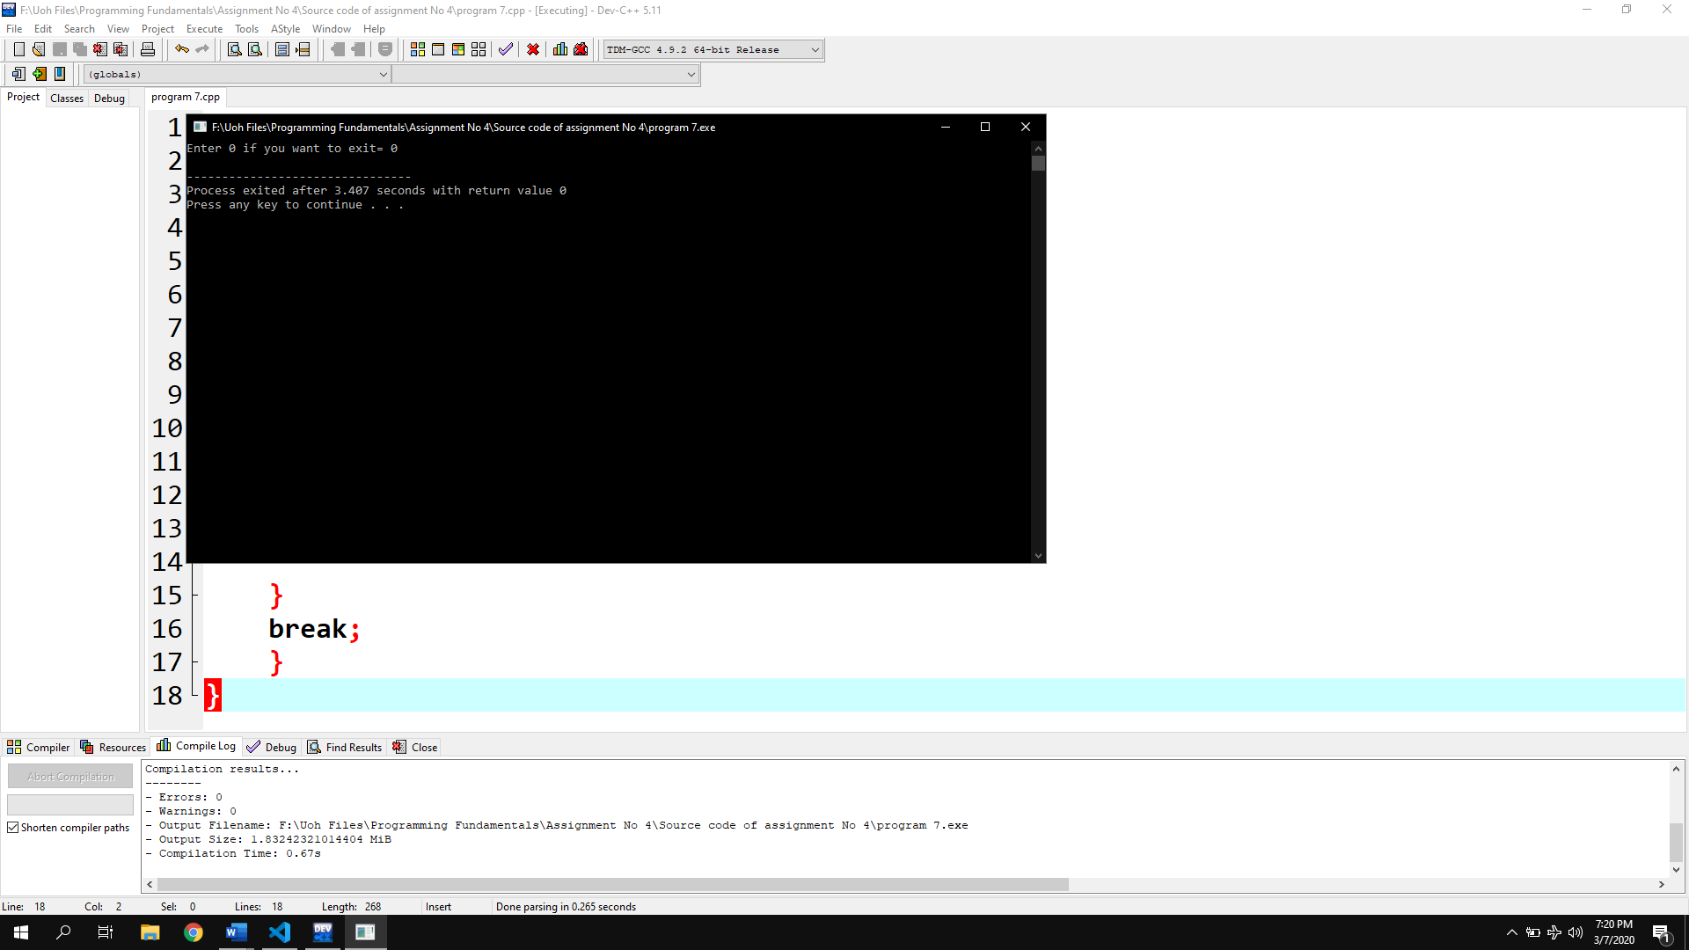

Program No 8:

|  |
| --- |
| #include <iostream>  using namespace std;  int main()  {int number ,fact;  cout <<"Enter the number of Factorial= ";  cin>>number ;  for (fact=1;number>=1;number--){fact*=number;}  cout <<"Factorial is "<< fact ;} |

Output:

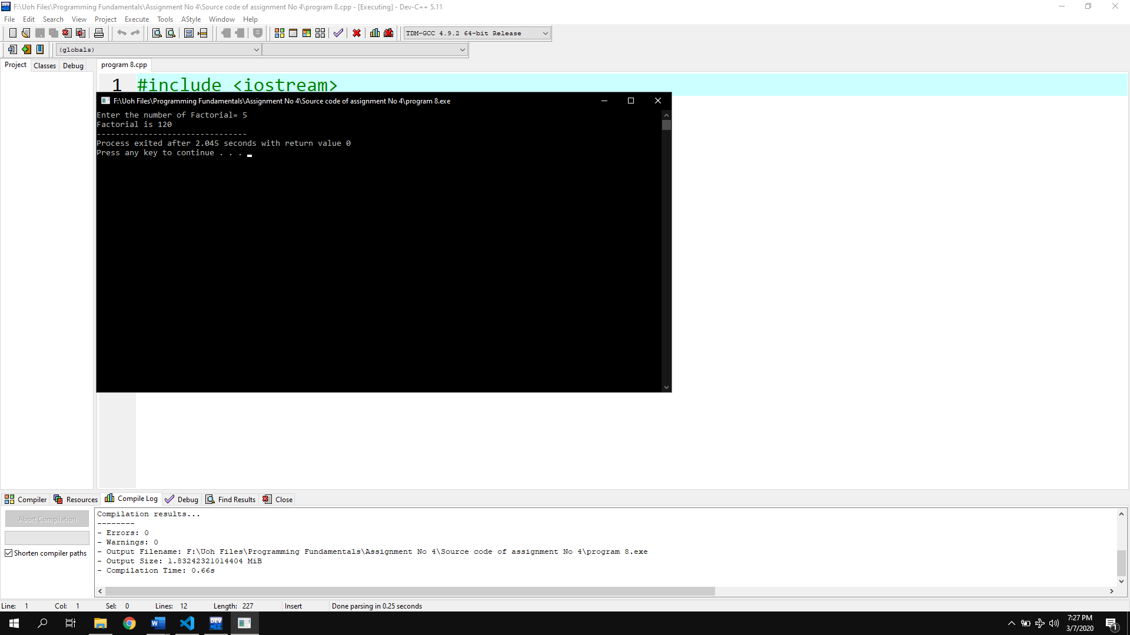

Program No 9:

|  |
| --- |
| #include <iostream>  using namespace std;  int main()  { int t1 = 0, t2 = 1, nextTerm = 0, n;  // displays the first two terms which is always 0 and 1  cout << "Fibonacci Series: " << t1 << ", " << t2 << ", ";  nextTerm = t1 + t2;  while(nextTerm <= 100)  {cout << nextTerm << ", "; t1 = t2;t2 = nextTerm;nextTerm = t1 + t2;}} |

Output:

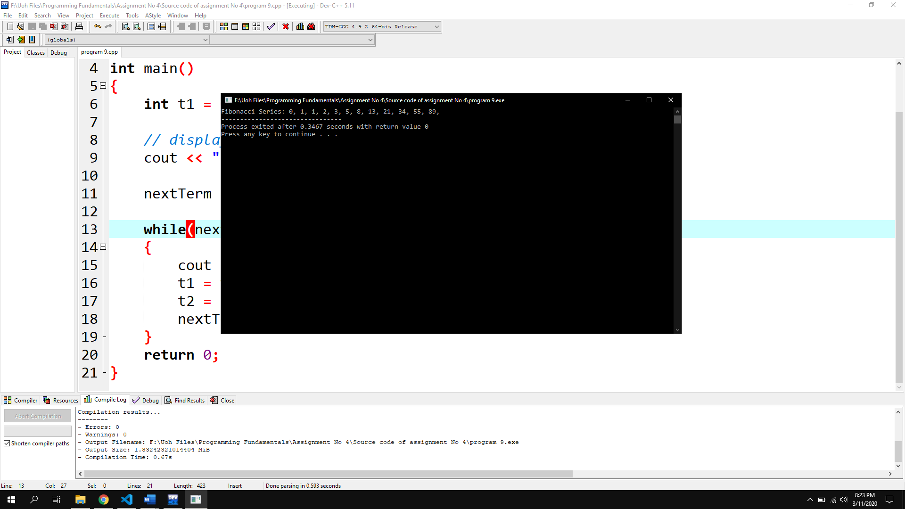

Program No 10(Flowchart):

|  |
| --- |
| #include <iostream>  using namespace std;  int main()  { int counter=1;  while (counter<=10)  {cout<<counter;counter++;}} |

Output:

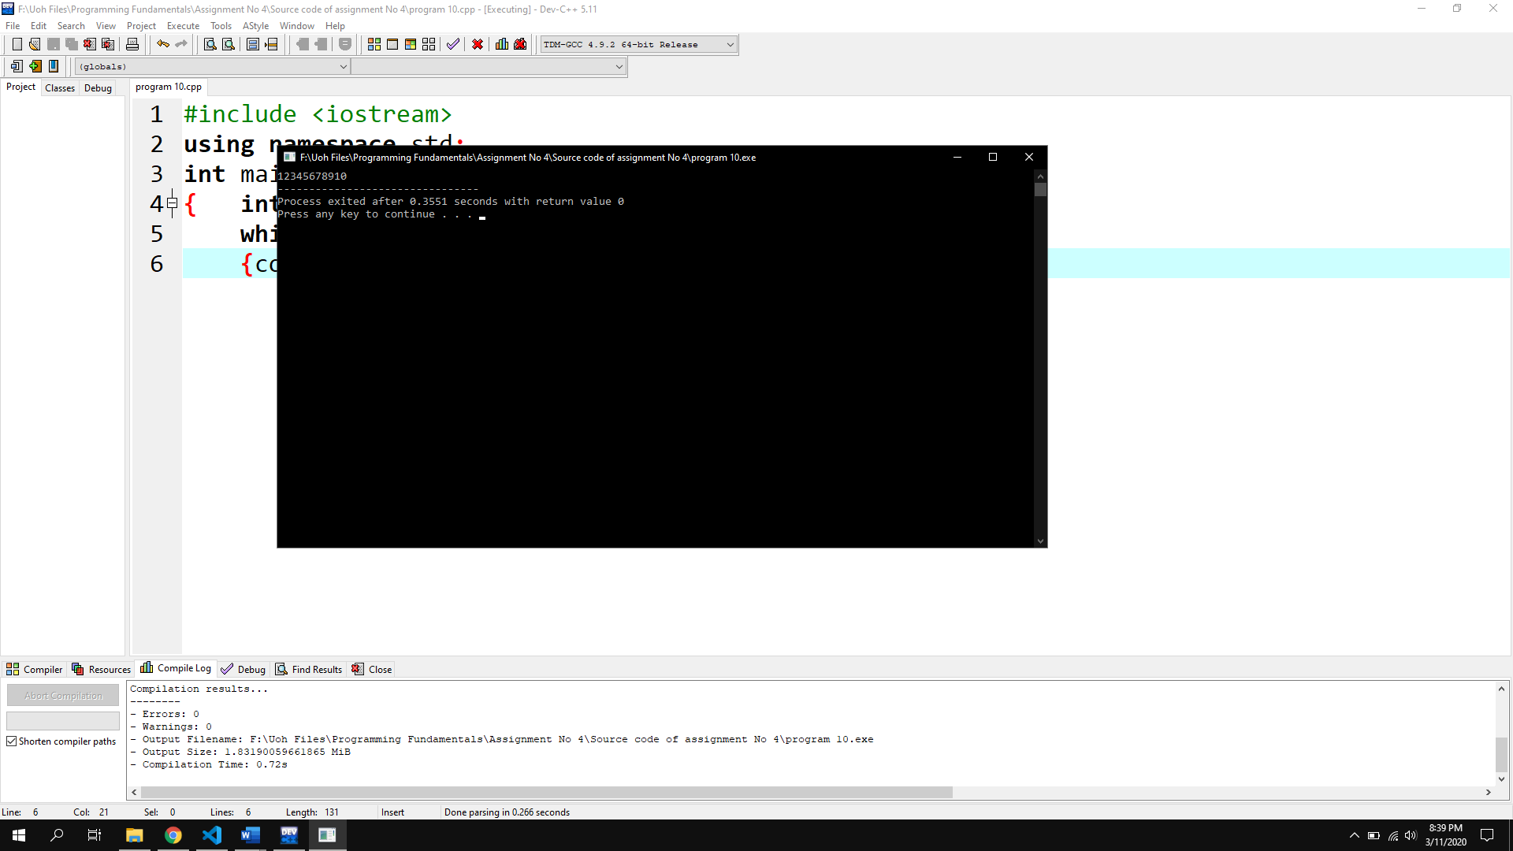

Program No 11:

|  |
| --- |
| #include <iostream>  using namespace std;  int main()  {int origNum, num, rem, sum = 0;  cout << "Enter a positive integer: ";cin >> origNum;num = origNum;  while(num != 0)  {rem = num % 10;  sum += rem * rem * rem;  num /= 10;}  if(sum == origNum) cout << origNum << " is an Armstrong number.";  else cout << origNum << " is not an Armstrong number.";} |

Output:

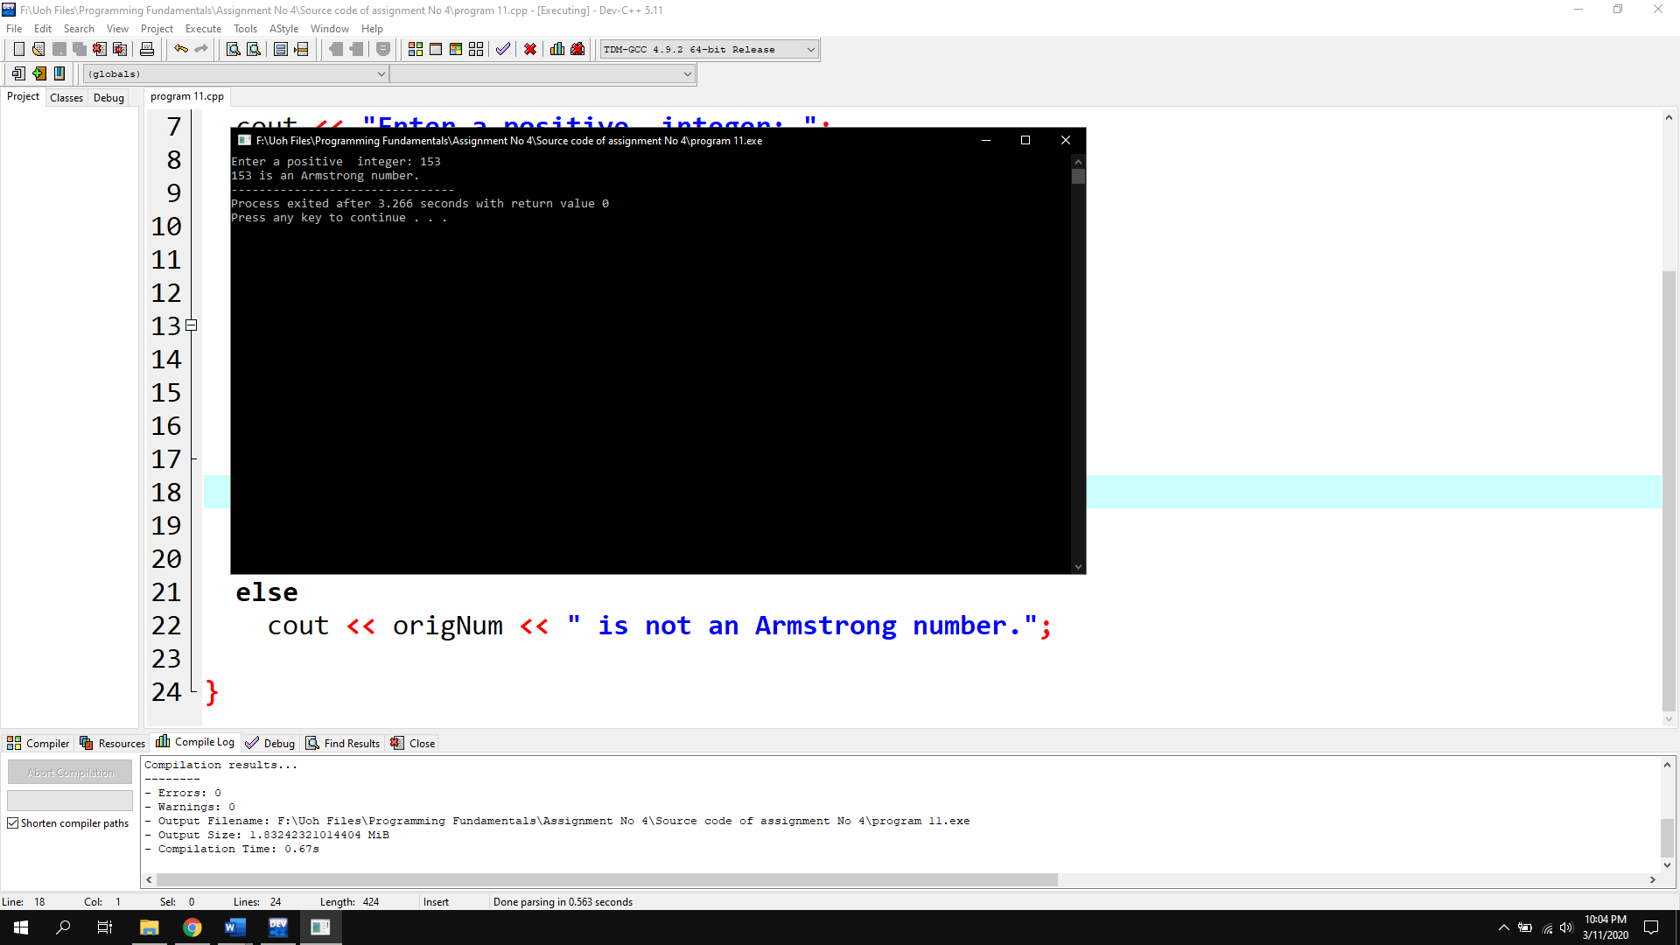

Program No 12:

|  |
| --- |
| #include <iostream>  using namespace std;  int main()  { int a,b,c,choice;  cout<<"Enter Number 0 for termination=";  cin>>choice;  while(choice!=0){  cout<<"Enter three numbers=\n";cin>>a>>b>>c;  if(a>b && a>c){cout<<"a is greater\n";}  else if(b>a && b>c){cout<<"b is greater\n";}  else if(c>a && c>a){cout<<"c is greater\n";}  else {cout<<"numbers are equal";cin>>choice;}  cout<<"Enter Number 0 for termination=";cin>>choice;}}} |

Output:

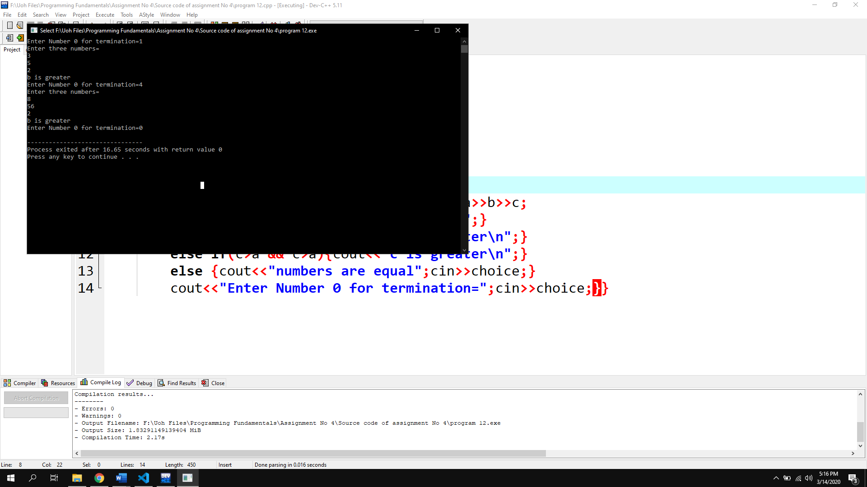

Program No 13:

|  |
| --- |
| #include <iostream>  using namespace std;  int main()  { for(int i=1;i<=12;i++)  {for (int j = 1; j < 13; j++)  {cout<<"\t"<<i*j;}cout<<"\n";}} |

Output:

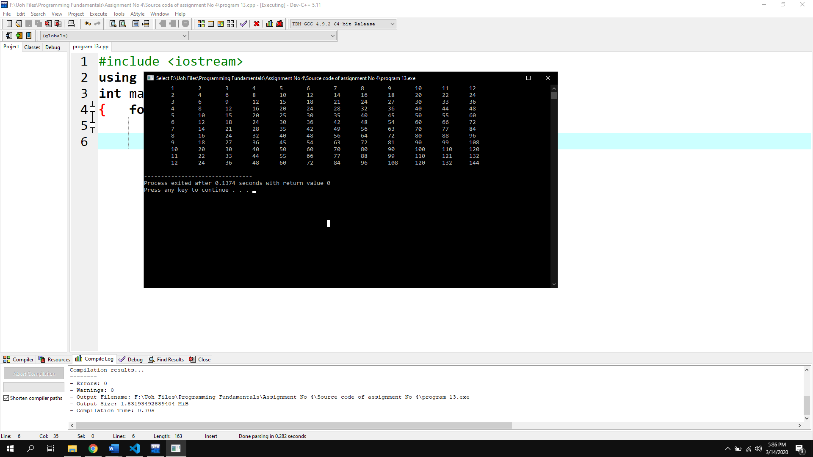

Program No 14:

|  |
| --- |
| #include <iostream>  using namespace std;  int main()  { int i=1;  while(i<5)  { int j=1;  while (j<=i)  {cout<<j;j++;}cout<<"\n";i++;}} |

Output:

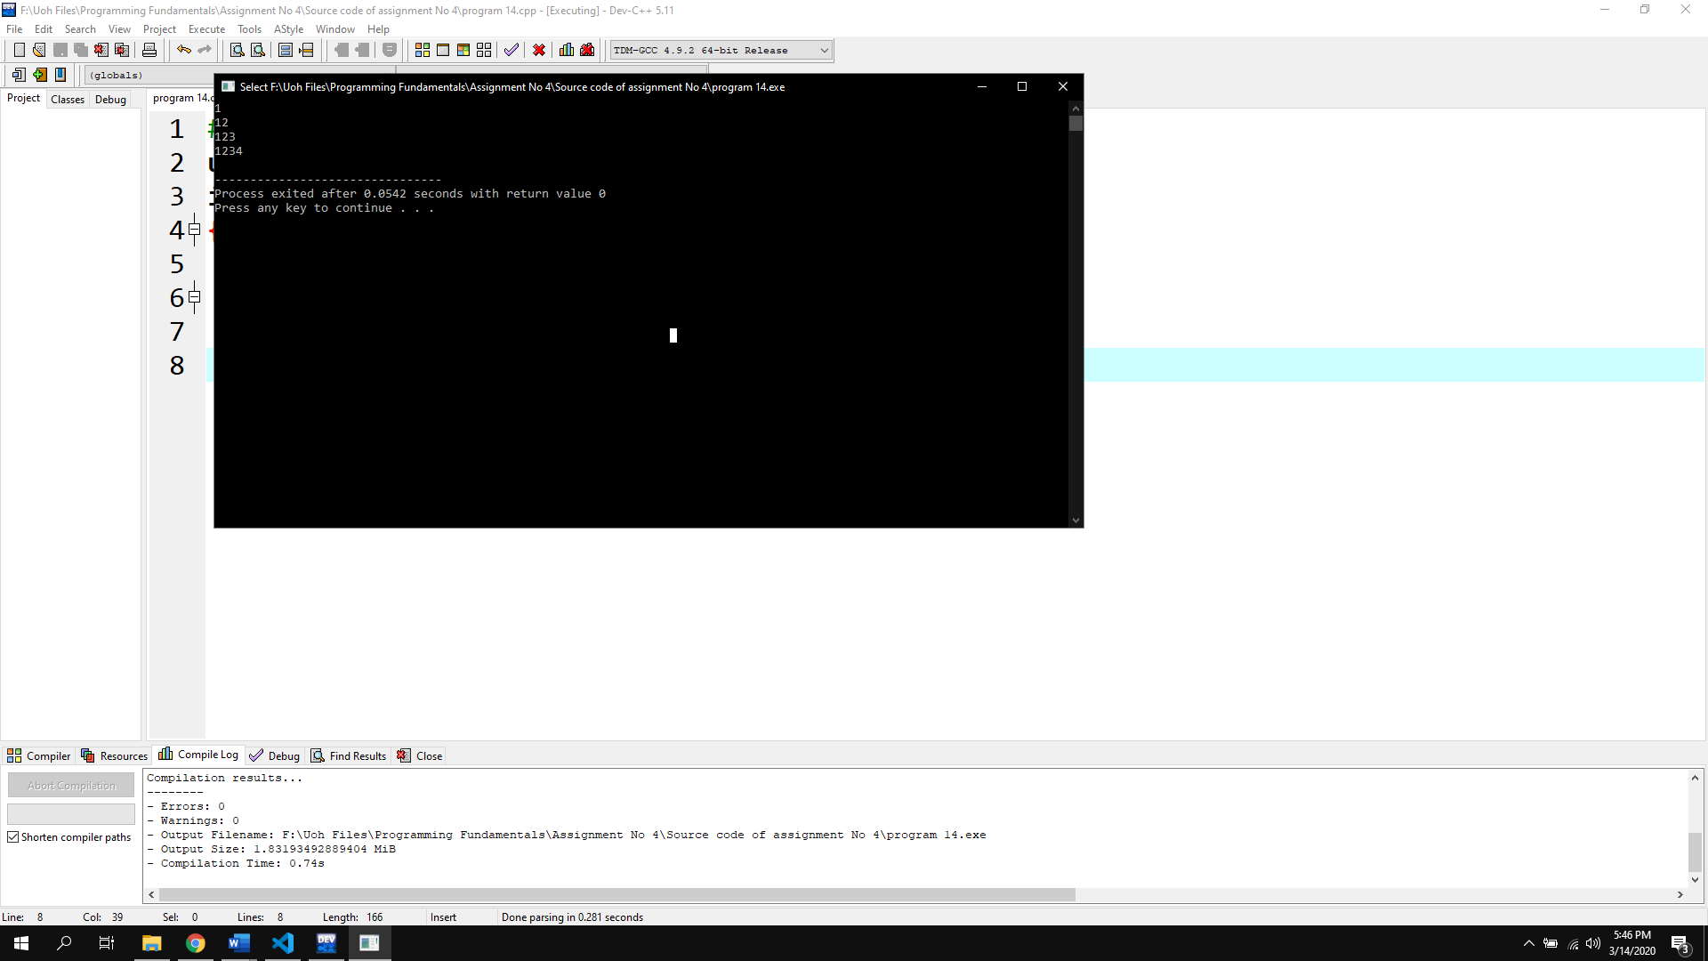

Program No 15:

|  |
| --- |
| #include <iostream>  using namespace std;  int main()  { int i=1;  while(i<5)  { int j=1;  while (j<=i)  {cout<<i;j++;}cout<<"\n";i++;}} |

Output:

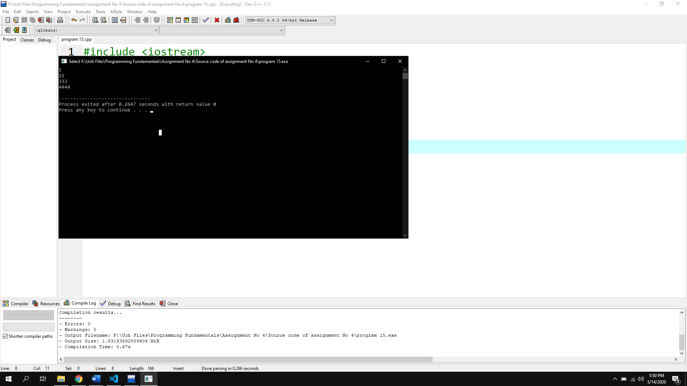

Program No 16:

|  |
| --- |
| #include <iostream>  using namespace std;  int main()  { int i=1, k=1, n=1;  while (i<=4)  {while (k<=i)  {cout<<n<<" ";n+=1;k+=1;}cout<<endl;i+=1;k=1;}} |

Output:

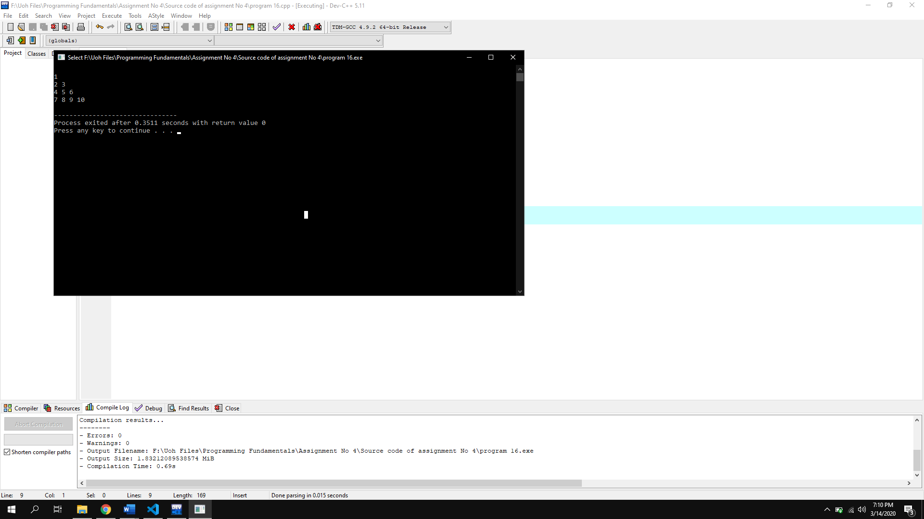

Assignment No # 05

Program No 1:

|  |
| --- |
| #include <iostream>  using namespace std;  int main()  { int i=0,sum=0,var;  cout<<"Input a number= ";cin>>var;  do{ sum+=i;i++;  }while (i<=var);cout<<sum;} |

Output:

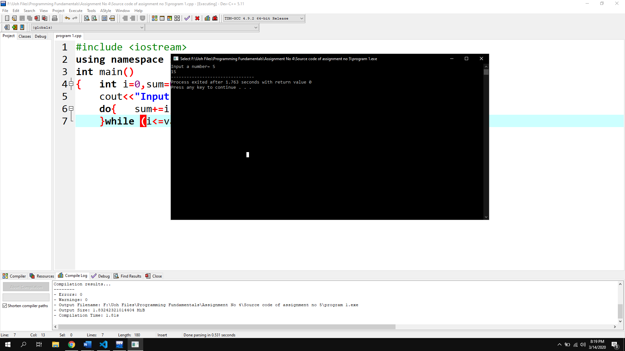

Program No 2:

|  |
| --- |
| #include <iostream>  using namespace std;  int main()  { int number ,fact;char g;  do  { cout<<"Enter the number of Factorial= ";  cin>>number ;  for (fact=1;number>=1;number--){fact*=number;}  cout <<"Factorial is "<< fact ;  cout<<"\nEnter Y to get factorial=";cin>>g;  } while (g=='y');} |

Output:

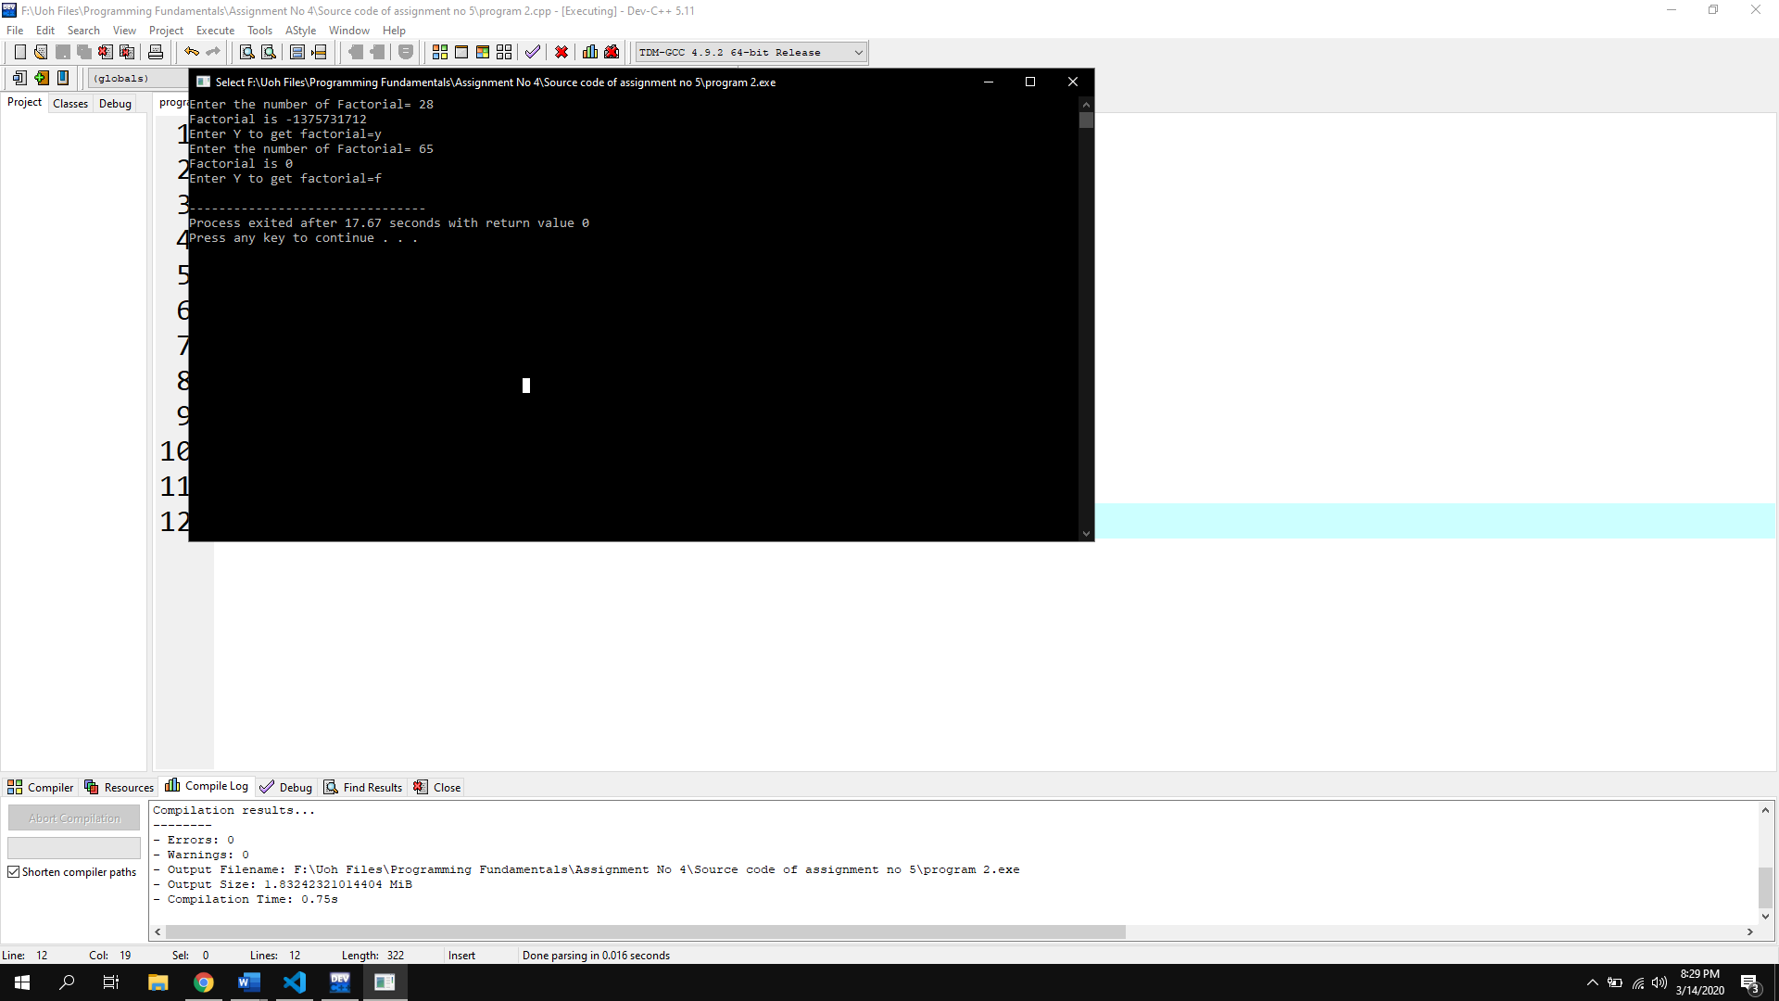

Program No 3:

|  |
| --- |
| #include <iostream>  using namespace std;  int main()  { int var1,var2;char oper,f;  do  {  cout<<"Enter two integers=";cin>>var1>>var2;  cout<<"Enter the operator=";cin>>oper;  switch (oper)  {  case '+':  cout<<var1+var2;  break;  case '-':  cout<<var1-var2;  break;  case '*':  cout<<var1*var2;  break;  case '/':  cout<<var1/var2;  break;    default:  cout<<"\nYou entered invalid number=";  break;  }  cout<<"\nPress Y to redo calculation=";cin>>f;  } while (f=='y'||f=='Y');} |

Output:

